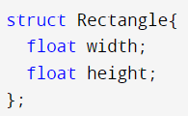

Consider the above structure

Write code that will:

1. Initialize a Rectangle called rect with a width of 5 and a height of 3

struct Rectangle rect = { 3, 5 };

struct Rectangle rect;

rect.height = 3;

rect.width = 5;

1. Initialize an array of 3 rectangles of any width and height

struct Rectangle rects[4] = { { 3, 4 }, { 10, 5 }, { 9, 2 } };

1. Write code that will print the area of the 2nd Rectangle in the array from question 2

printf("%f", rects[1].height \* rects[1].width );

More questions on page 2

struct

.

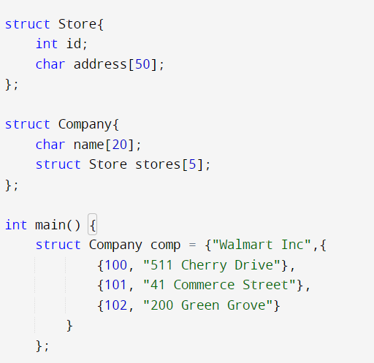

Consider the above code

1. Write code that will print the name of the Company stored in comp

printf("%s", comp.name);

1. Write code that will print the address of comp's third Store

printf("%s", comp.stores[2].address);

1. Write code that will add a fourth Store to comp

struct Store s1 = { 103, "300 Hill Street" };

comp.stores[3] = s1;

1. Write code that will initialize a Company with two Stores

struct Company comp2 = { "IKEA", {

{ 1000, "Drive" },

{ 2000, "Street" }

}

};